Relationship between machine learning, linear algebra and vectors and matrices.

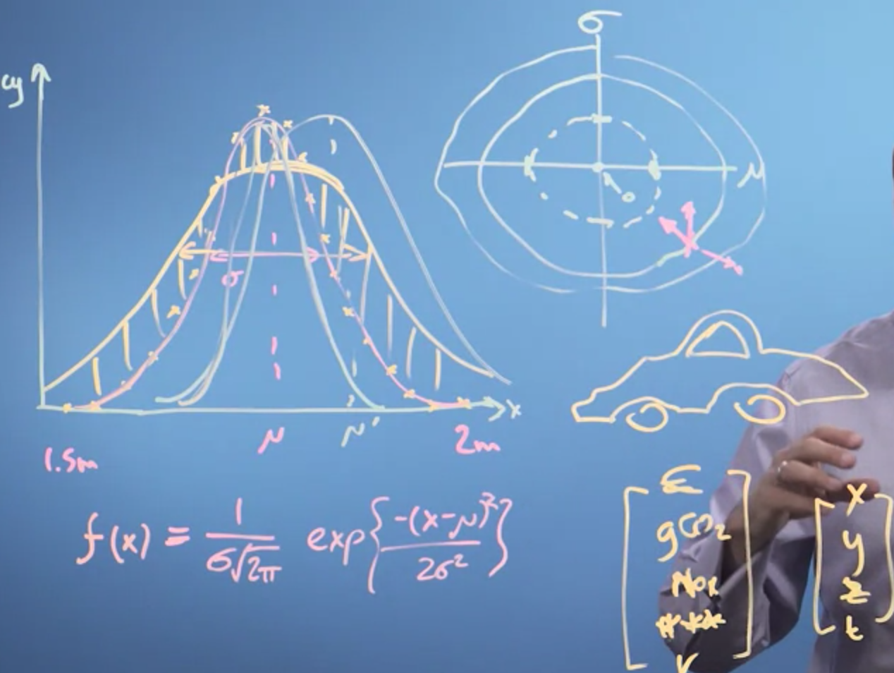

So, in this video, we've revisited the problem of fitting a function to some data, in this case, the distribution of heights in the population.

What we've seen is the function we fit, whatever it is, has some parameters. And we can plot how the quality of the fit, the goodness of the fit, varies as we vary those parameters. Moves around these fitting parameter space are then just vectors in that space of fitting parameters. And, therefore, we want to look at and revisit vector maths in order to be able to build on that, and then do calculus, and then do machine learning.

House – Vector , that describes that object.

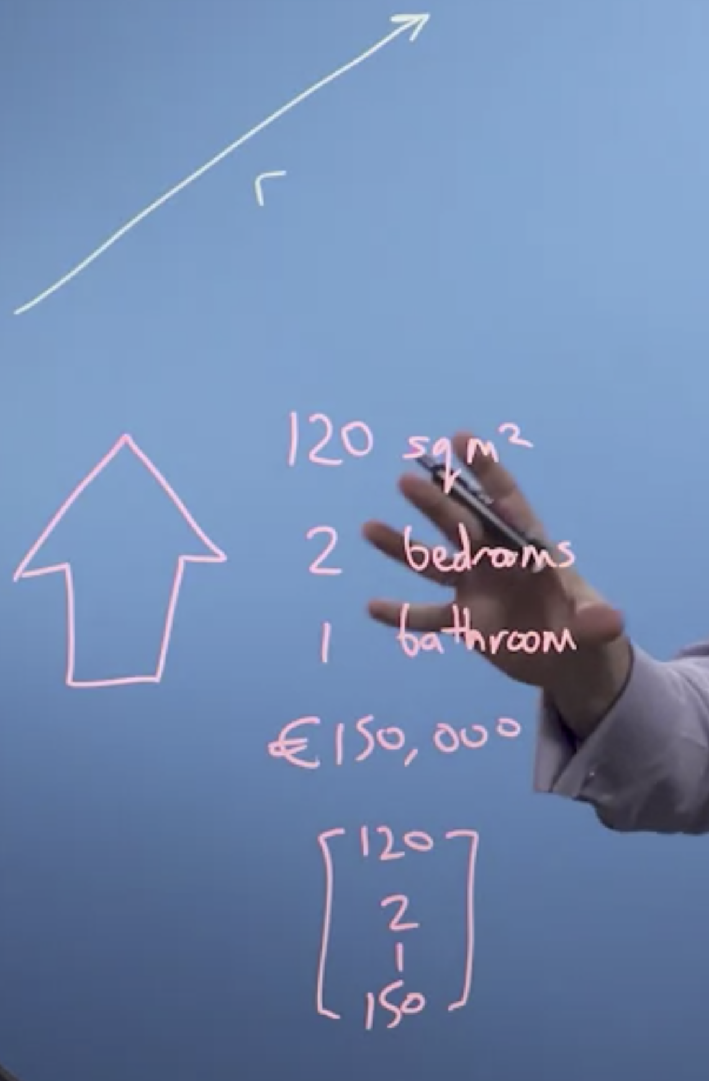

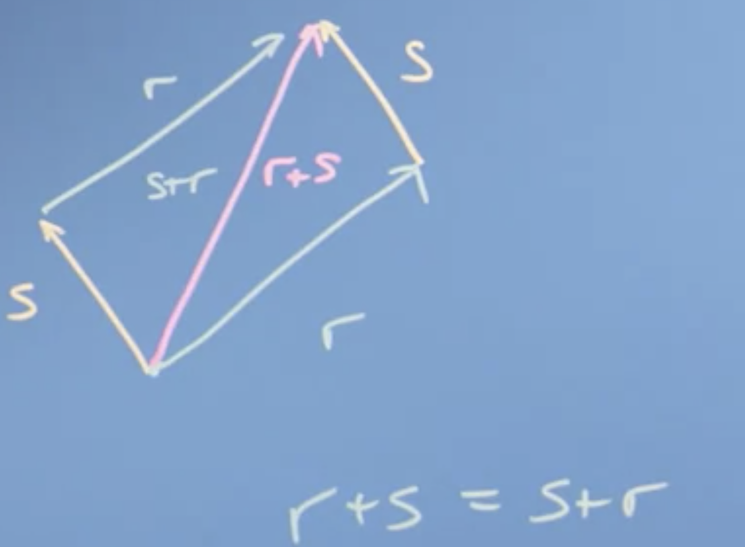

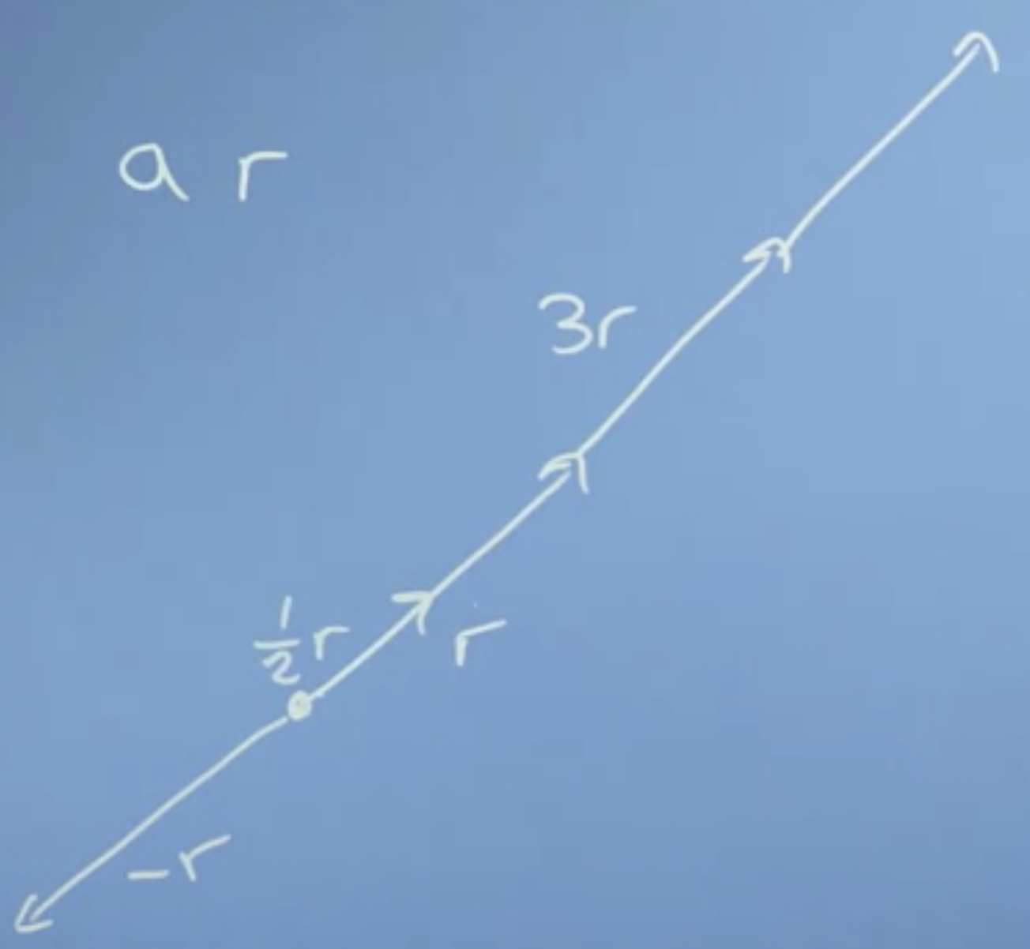

Unit vectors to describe the space. I , j . Vector addition is associative.

Vector operations: Addition and scalar multiplication.

Size and dot product of the vector:

Dot product also called it’s inner scalar or projection product.

Size of the vector is the sums of the square of the components and taking a square root.

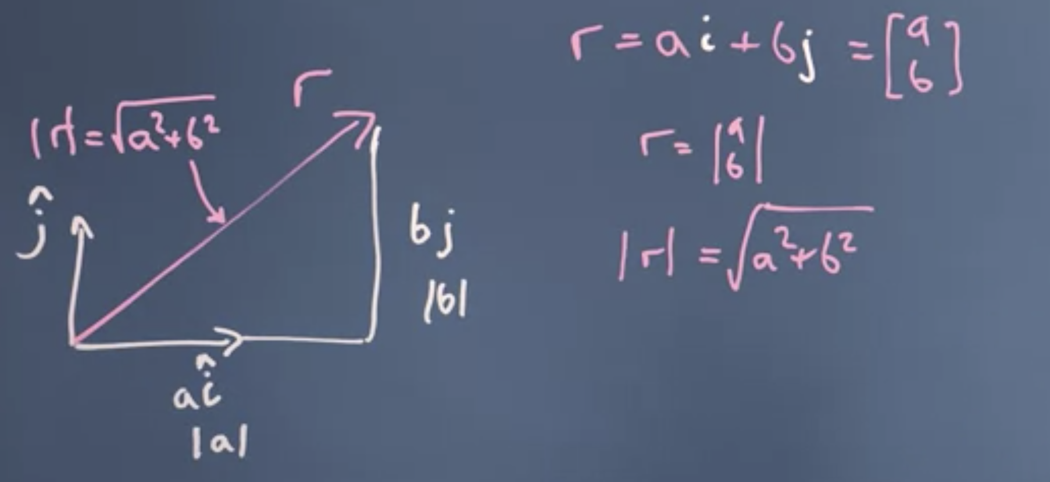

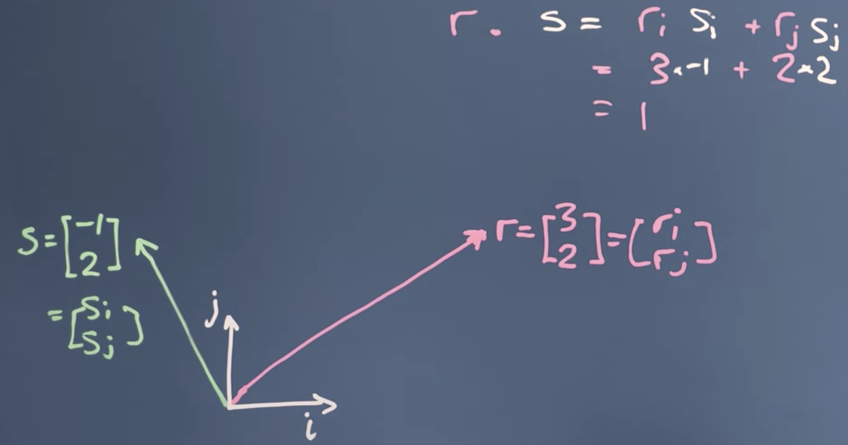

Commutative: dot product.

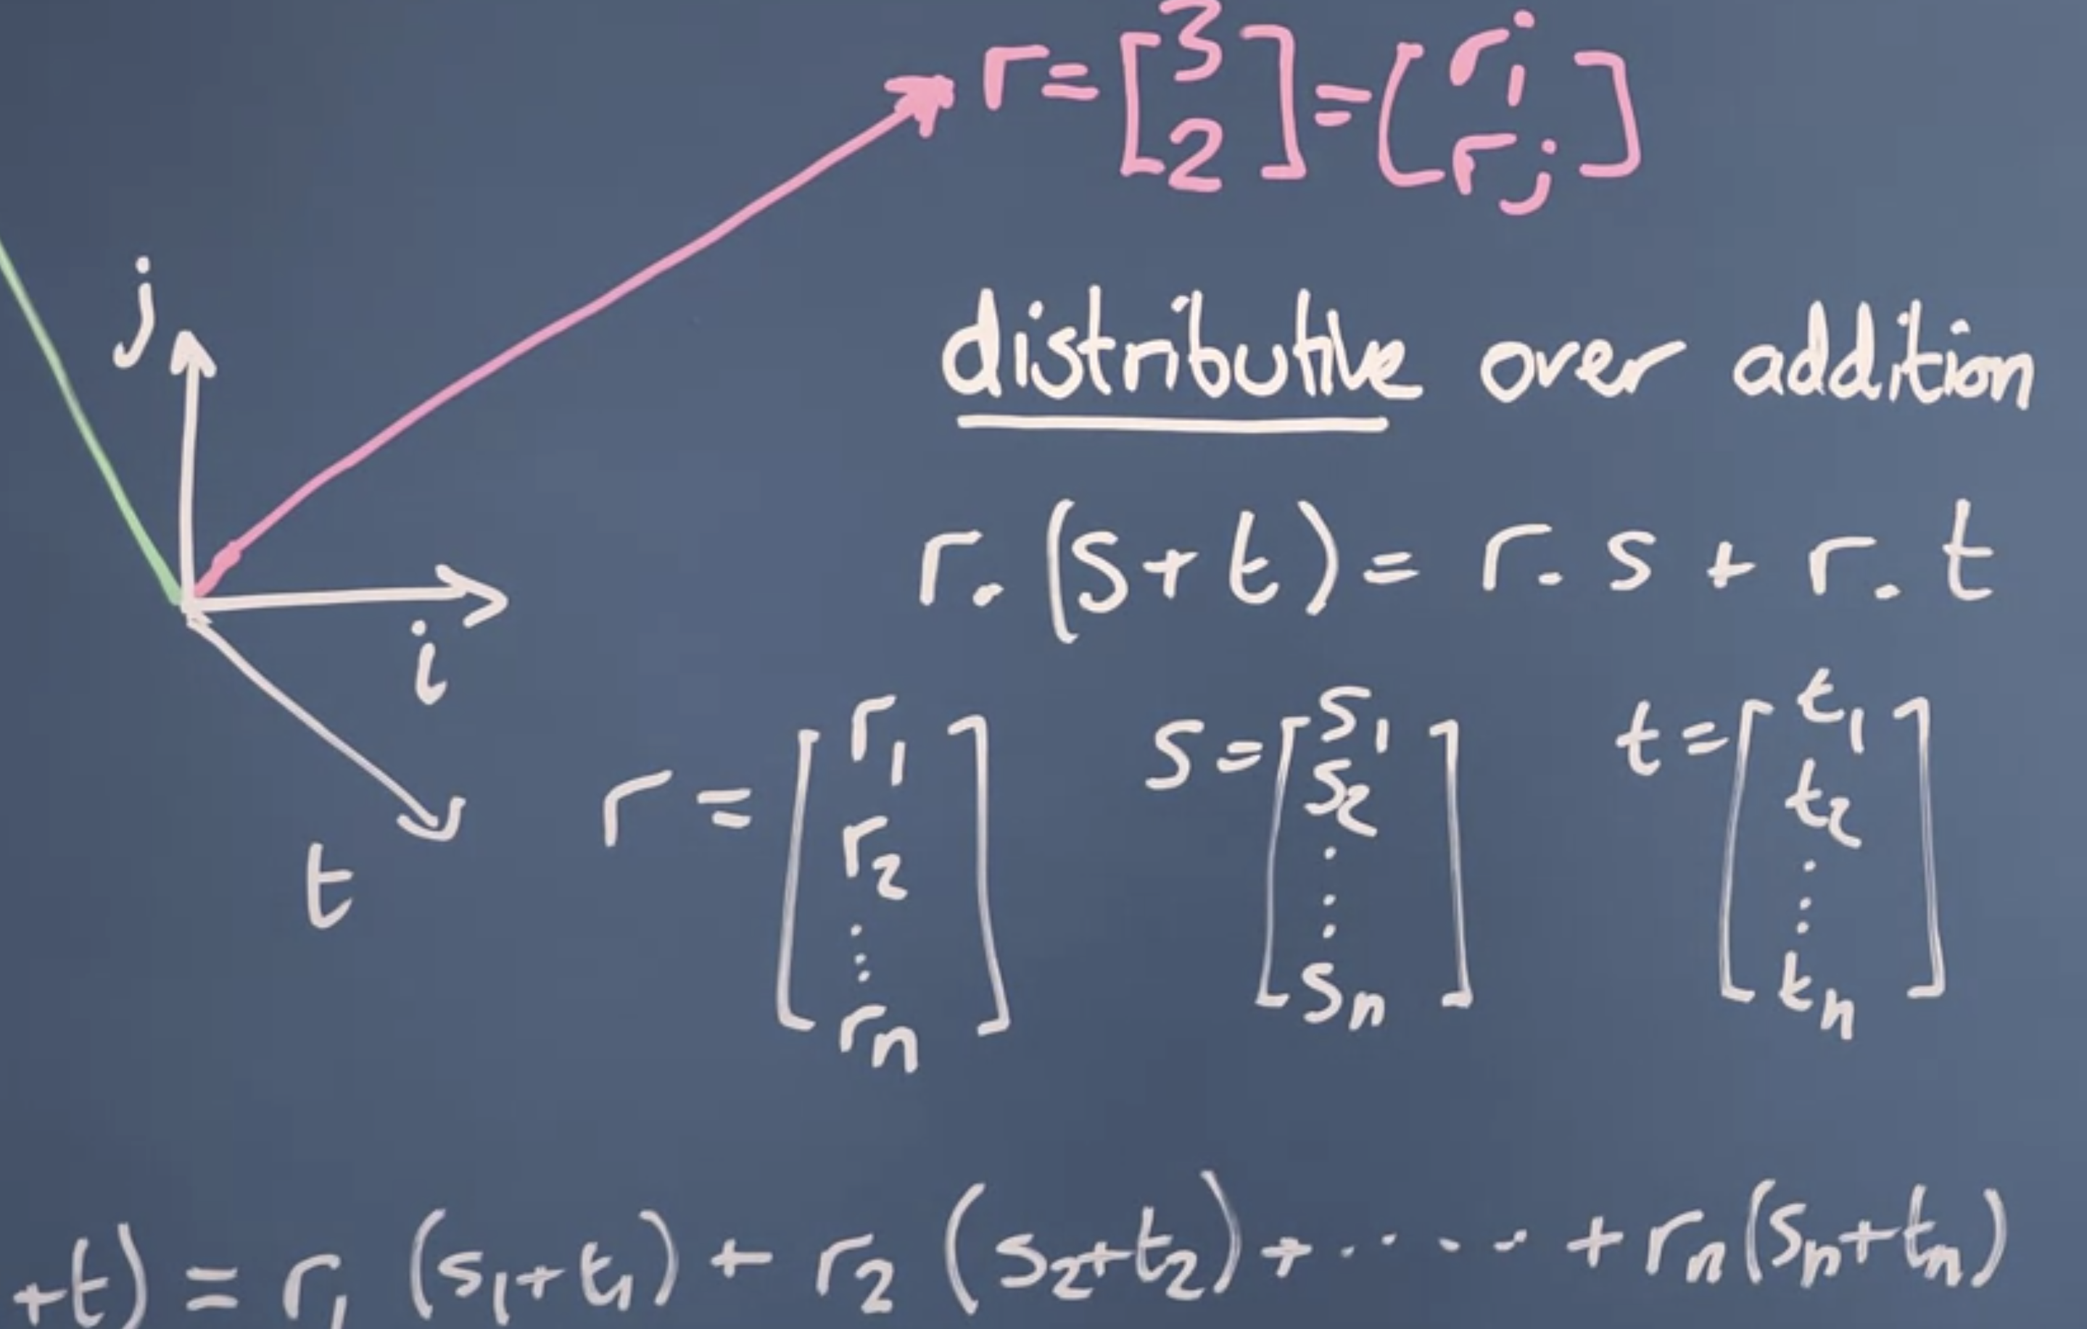

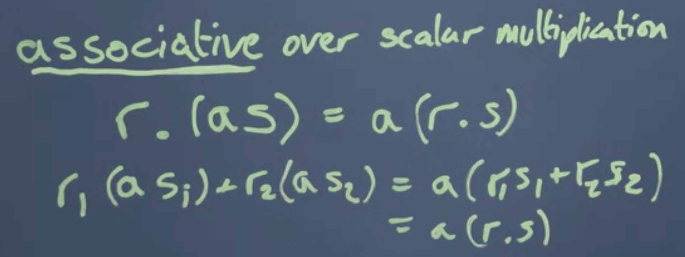

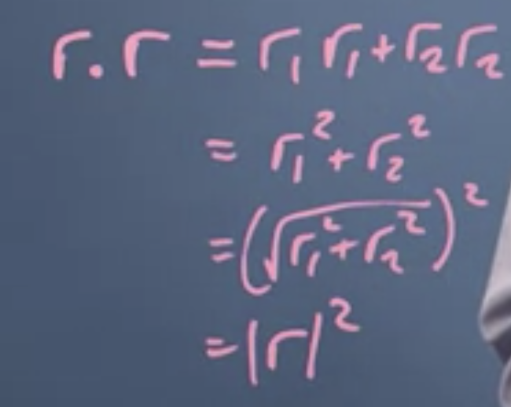

Take the dot product of a vector to itself and then take the square root of it to get the magnitude of the size.

Cosine and Dot Product.

Using the cosine rule, we can find the direction of two vectors with respect to each other.

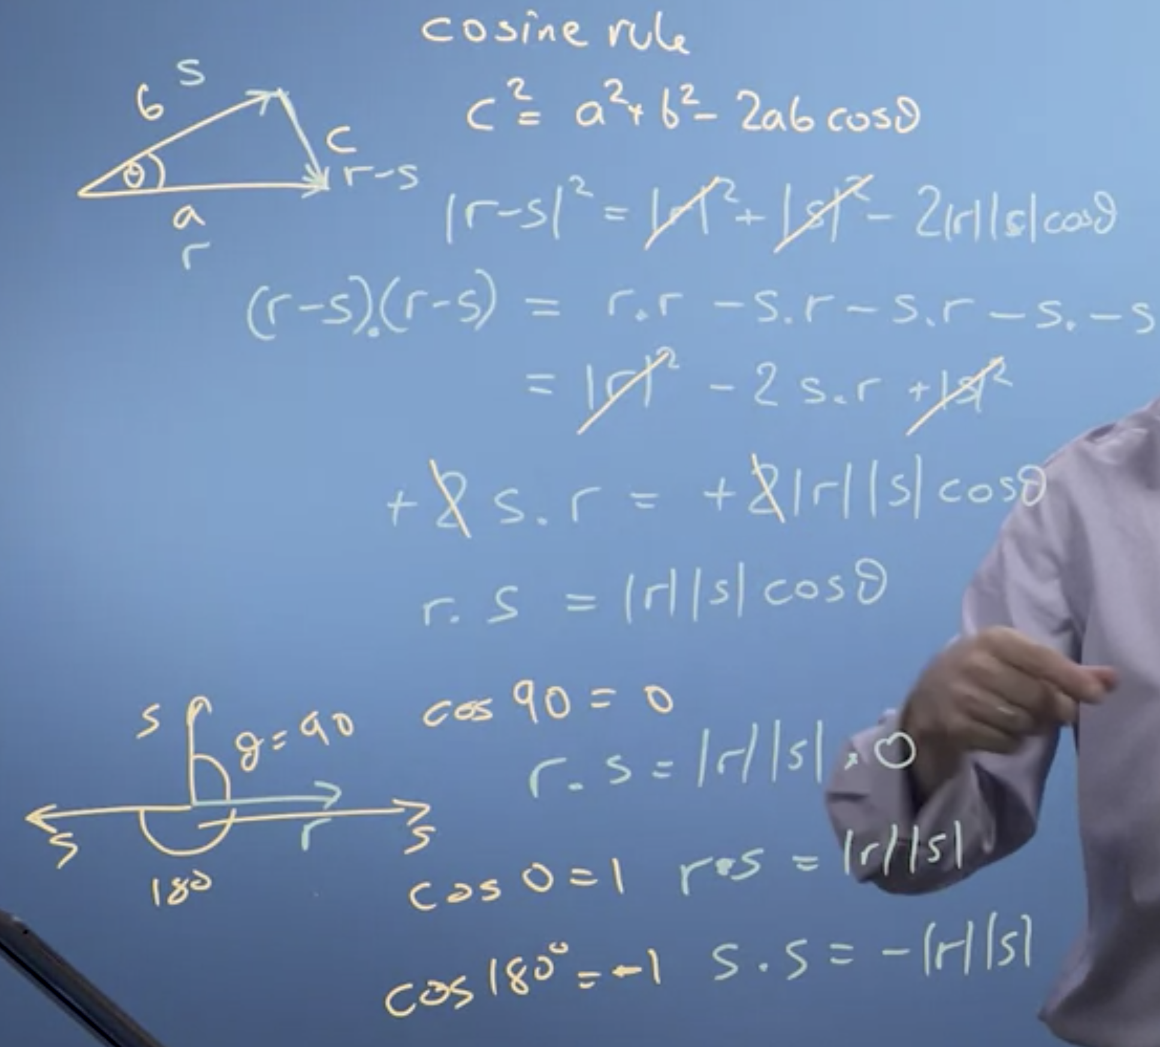

Projection:

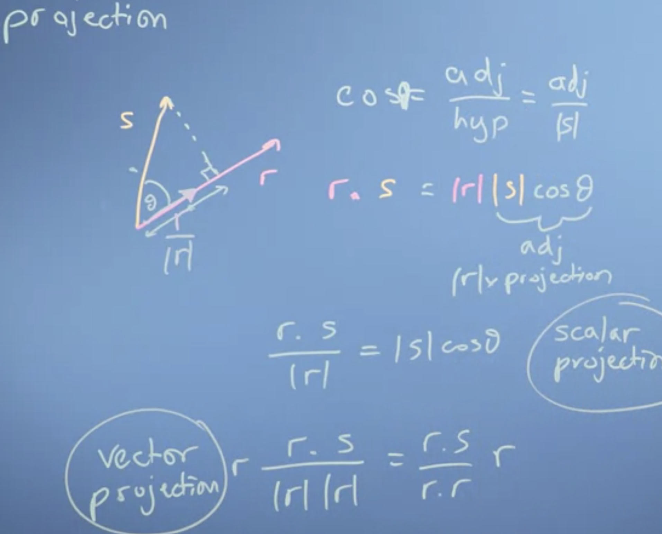

**Cosine**. is the horizontal coordinate of the arc endpoint. A convenient mnemonic for remembering the definition of the sine, **cosine**, and tangent is SOHCAHTOA (sine equals opposite over **hypotenuse**, **cosine** equals **adjacent** over **hypotenuse**, tangent equals opposite over **adjacent**).

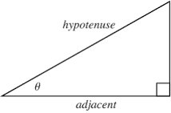

Vector projection:

Scalar projection = r.s / |r|

Component of s in the direction of r: vector project. In this case, you take the normalized (unit vector) r / |r| times the scalar projection of s onto r.

**Changing the reference frame:**

New basis vector have to orthogonal to each other.

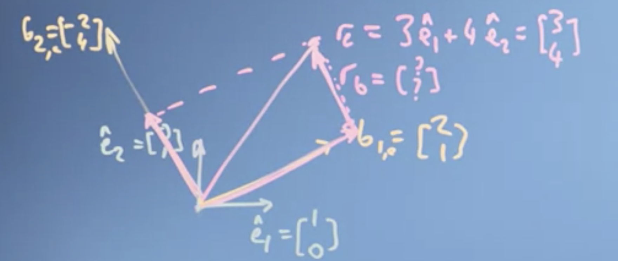

Using dot-products in this special case where the new basis vectors are orthogonal to each other, is computation a lot faster and easier, it's just less generic. But if you can arrange the new axis to be orthogonal, you should, because it makes the calculations much faster and easier to do. So, you can see that if I project r down onto b1, so I look down from here, and project down at 90 degrees, I get a length here for scalar product, and that's scalar projection is the shadow of r to b1. A number of the scalar projection describes how much of this factor I need. The vector projection is going to actually give me a vector in the direction of b1, of length equal to that projection. Now, if I take the vector projection of r onto b2 going this way, I'm going to get a vector in the direction of b2 of length equal to that projection. If I do a vector sum of that vector projection, plus this guy's vector projection, I'll just get r

So in the basis of b1 and b2, rb is going to be two a half. Very nice. Two a half. So actually in the basis b it's going to be two a half there. So rb is 2 times b1 plus a half times b2.

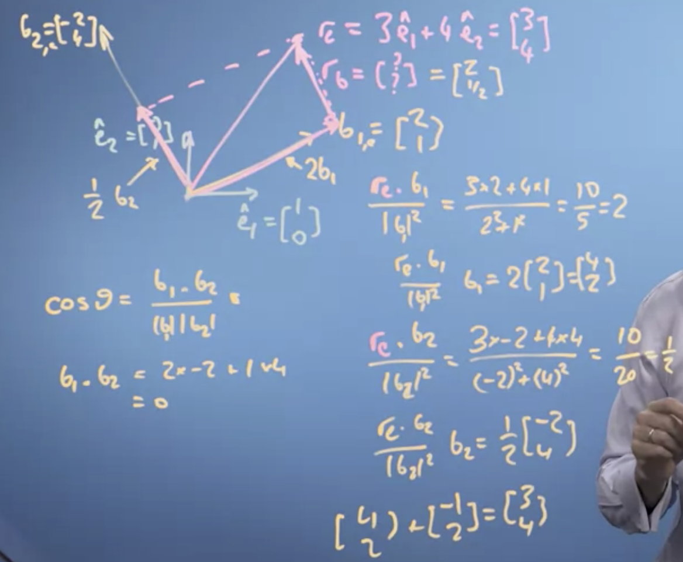

We've seen that a vector describing our data, isn't tied to the axes that we originally used to describe it at all. We can re-describe it using some other axis, some other basis vectors. So the basis vectors were use to describe the space of data, and choosing them carefully to help us solve a problem will be a very important thing in any algebra, and in general. What we've seen is we can move the numbers in the vector, we use to describe a data item from one basis to another. We can do that change just by taking the dots or projection product, in the case where the new basis vectors are orthogonal to each other.

we've seen how we don't just have to have basis vectors that are our normal one hour and 01, the so-called natural basis. We can have different basis vectors that we define how we move about space. In this video, we're going to define what we mean by a basis, by a vector space, and by the term linear independence, which is going to let us understand how many dimensions our vector space possesses.

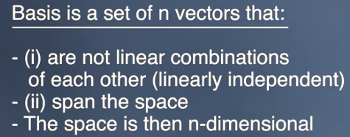

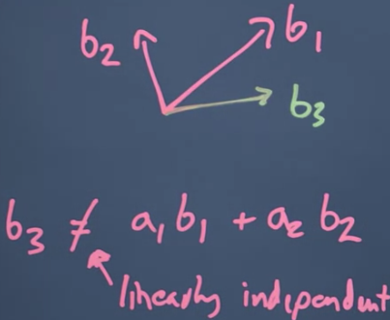

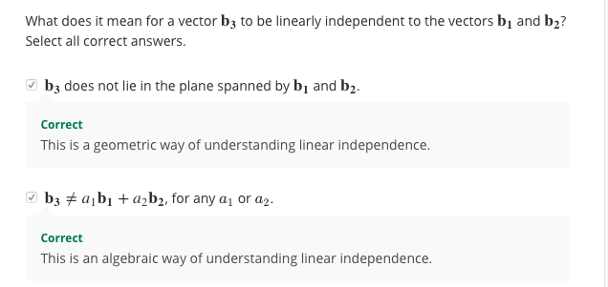

Now, notice what my basis vectors b don't have to be. They don't have to be unit vectors by which I mean vectors of length one and they don't have to be orthogonal, that is at 90 degrees to each other. But everything is going to be much easier if they are. So if at all possible, you want to use orthonormal basis factor sets, 90 degrees of unit length.

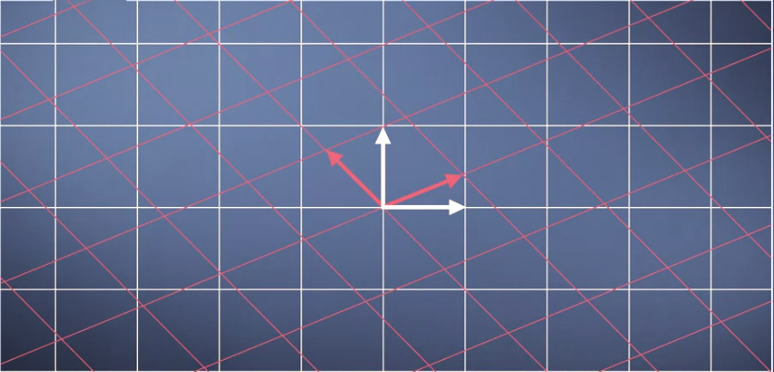

Now let's think about what happens when we map from one basis to another. The number line of the axis of the original grid then projects down onto the new grid and potentially has different values on that grid but the projection keeps the grid being **evenly spaced**. Therefore, any mapping we do from one set of basis vectors, from one coordinate system to another, keeps the vector space being a regularly spaced grid. Well, our original vector rules of vector addition and multiplication by a scalar still work. It doesn't [inaudible] fold space which is what the linear bit in linear algebra means. Things might be stretched or rotated or inverted, but everything remains evenly spaced and linear combinations still work.

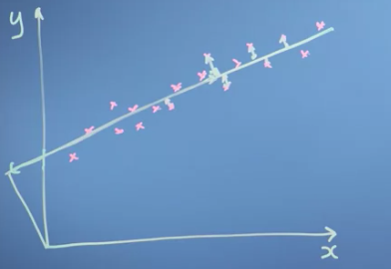

So when I'm doing data science it tells me how good my fit to my data is. The way I've defined these two directions along the line and away from the line, they are orthogonal to each other. So I can use the dot-product to do the projection to map the data from the x-y space unto the space of the line, along the line and away from the line, which is what we deal into in the last little segment. Now if we're thinking about a neural network in machine learning that recognizes faces say, maybe I'd want to make some transformation of all the pixels interface into a new basis that describes the nose shape, the skin hue, the distance between the eyes those sorts of things and discard the actual pixel data. So the goal of the learning process of the neural network is going to be to somehow derive a set of basis vectors that extract the most information-rich features of the faces.

Vector addition in this case. Think about it, you need to move from vector space to a 2 * in the direction of velocity vector.

S + 2* V = New position.

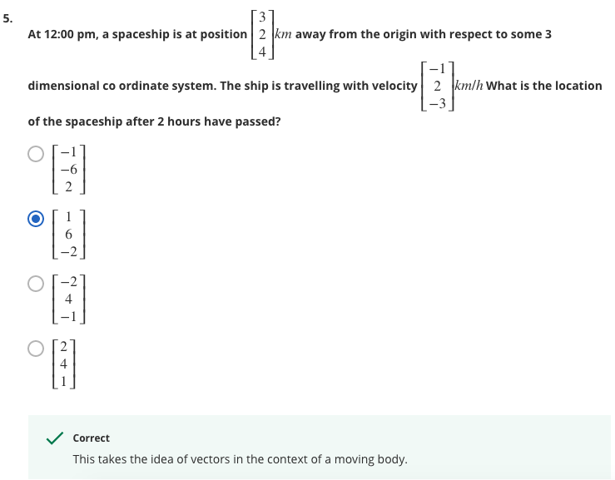

Matrices in Linear Algebra: Objects that operate on Vectors

Here we have just transformed using the matrix – Where does natural basis vectors land?

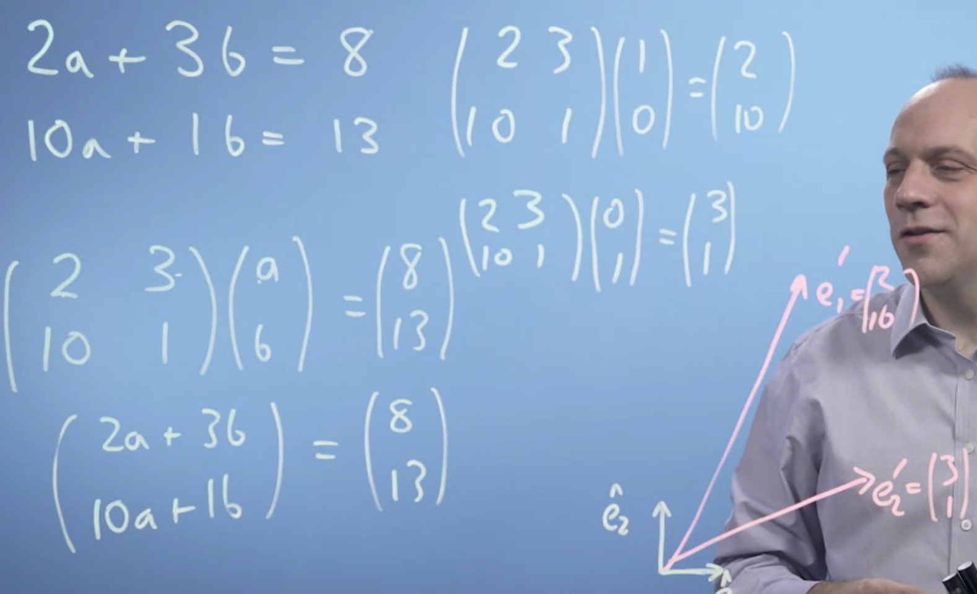

So what this matrix does, is it moves the basis vectors in some way, it transforms them, it changes the space.

Linear algebra is linear, because it just takes input values, our a and b, and multiplies them by constants. So everything is linear. And it's algebra, that is it's a notation describing mathematical objects and a system of manipulating those notations. So linear algebra is a mathematical system for manipulating vectors in the spaces described by vectors.

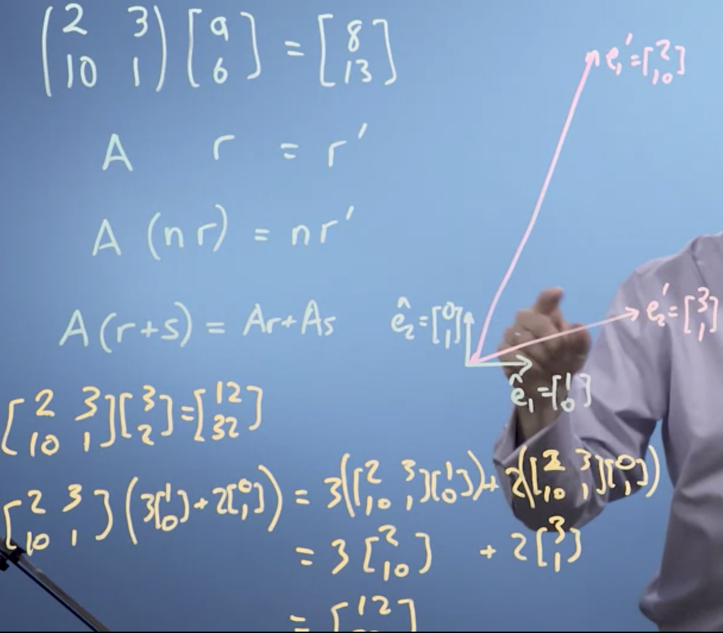

Identity Matrix

Multiple – Large

Fraction – Smaller

Negative – Change the orientation from right hand rule to a left-hand rule.

Inverse (Both are negatives)

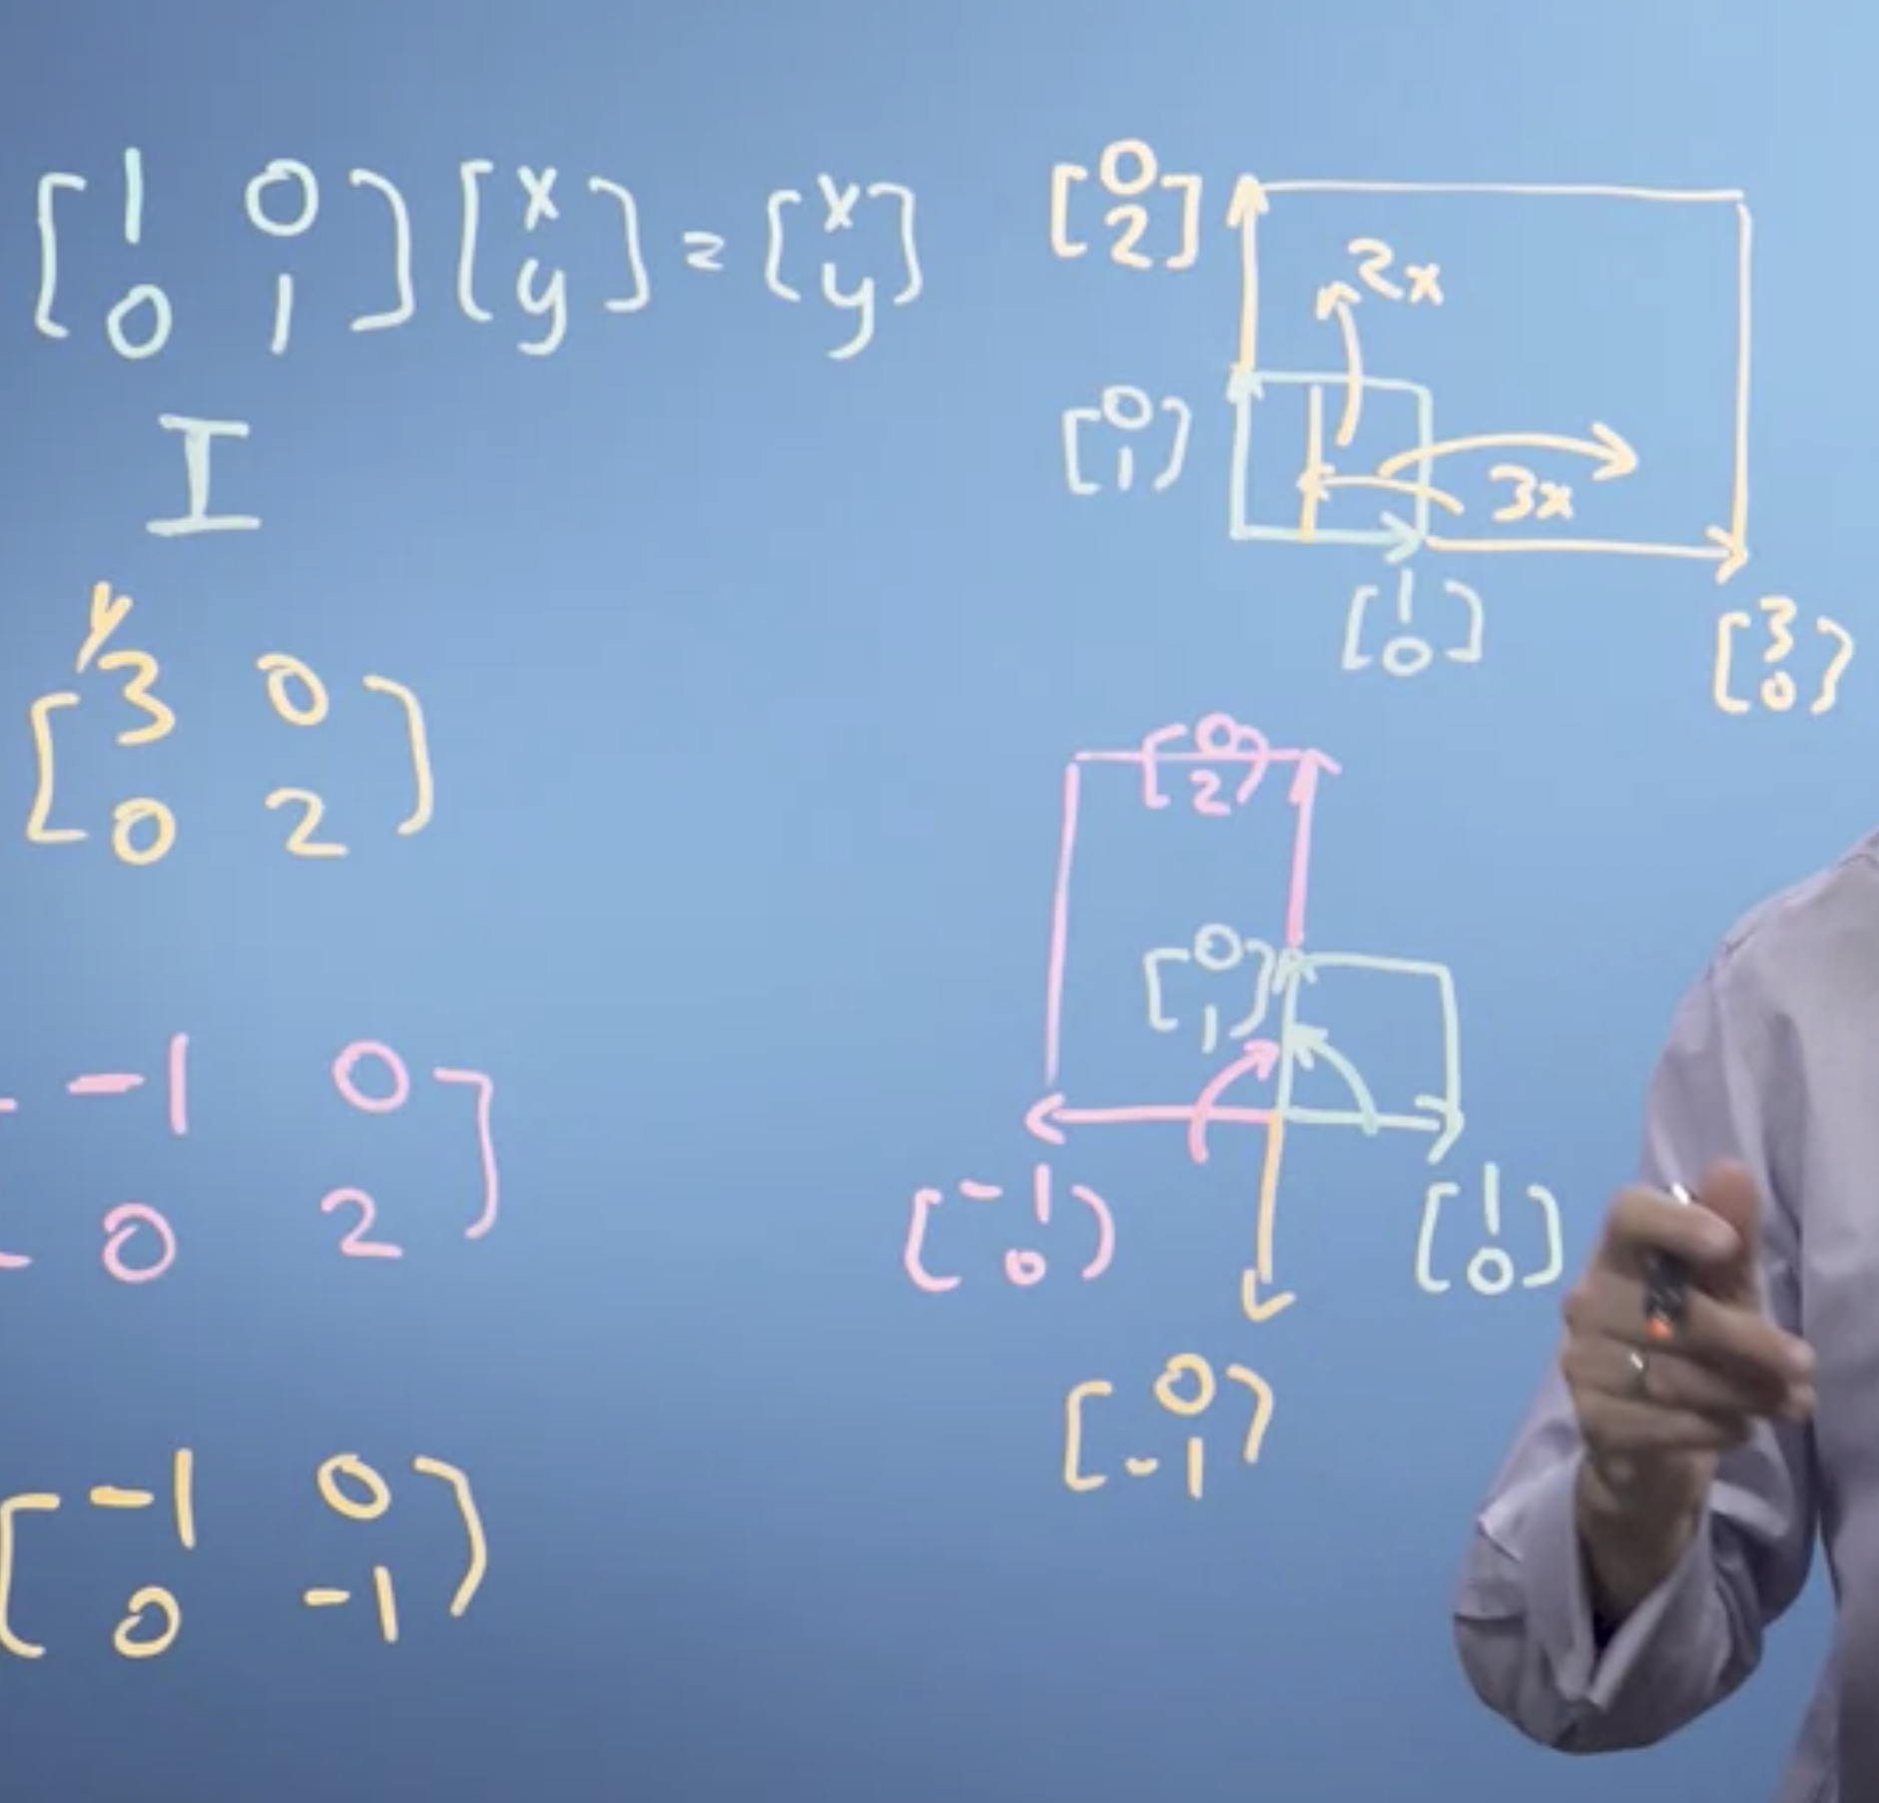

Mirrors:

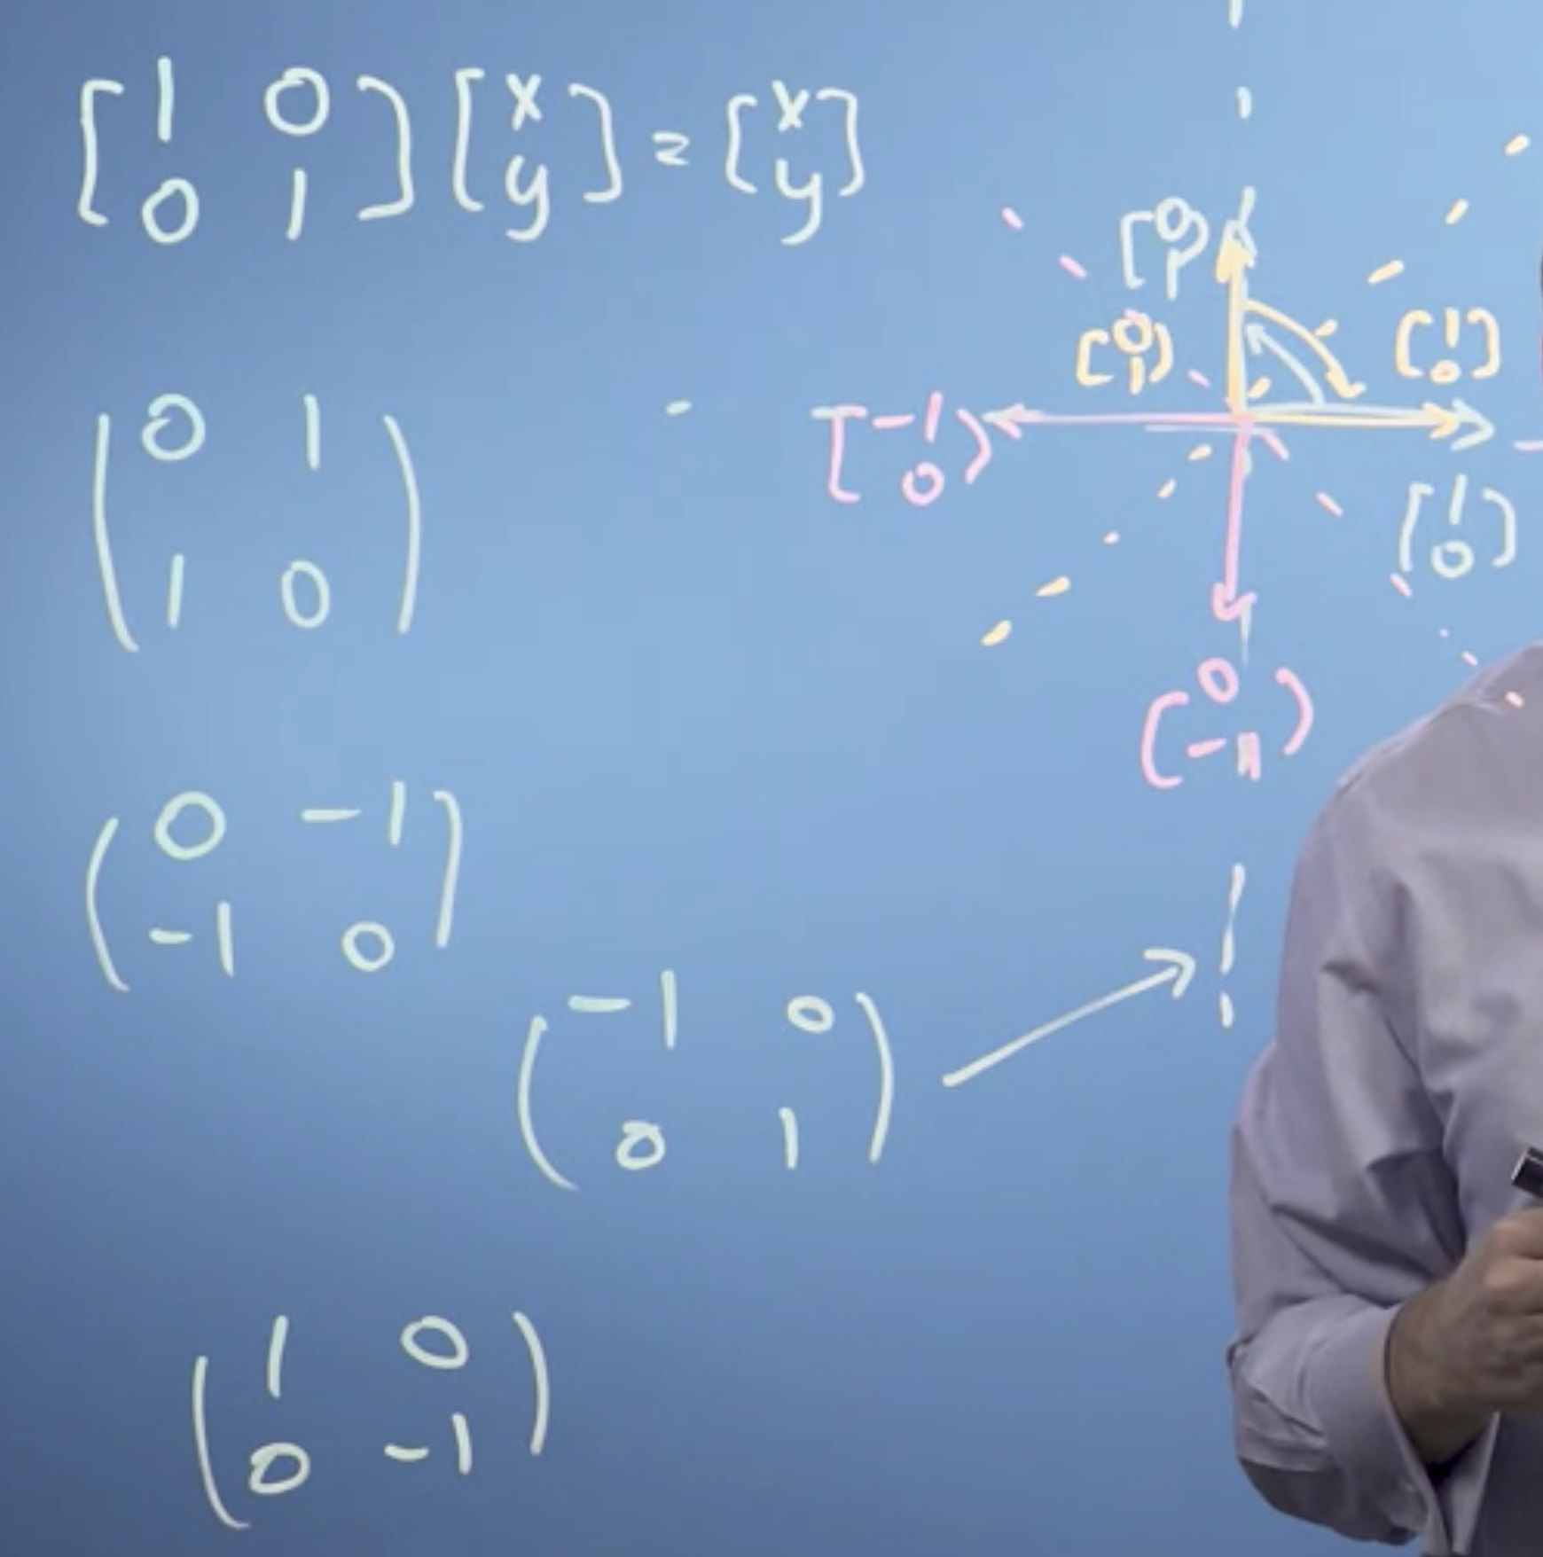

Shear.

Rotation.

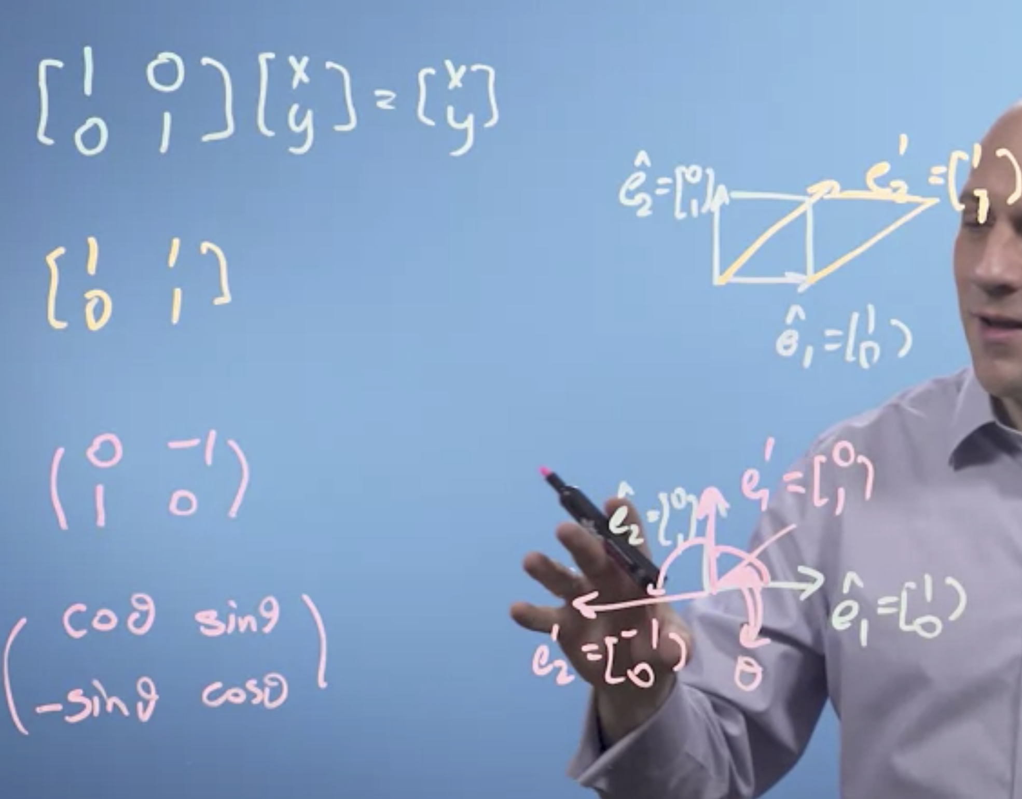

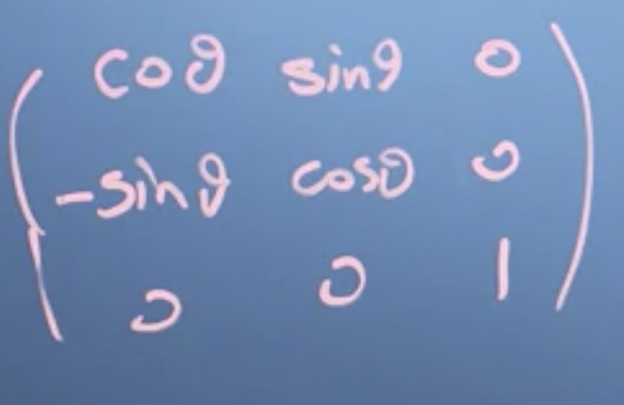

Matrix multiplication is not commutative but associative.

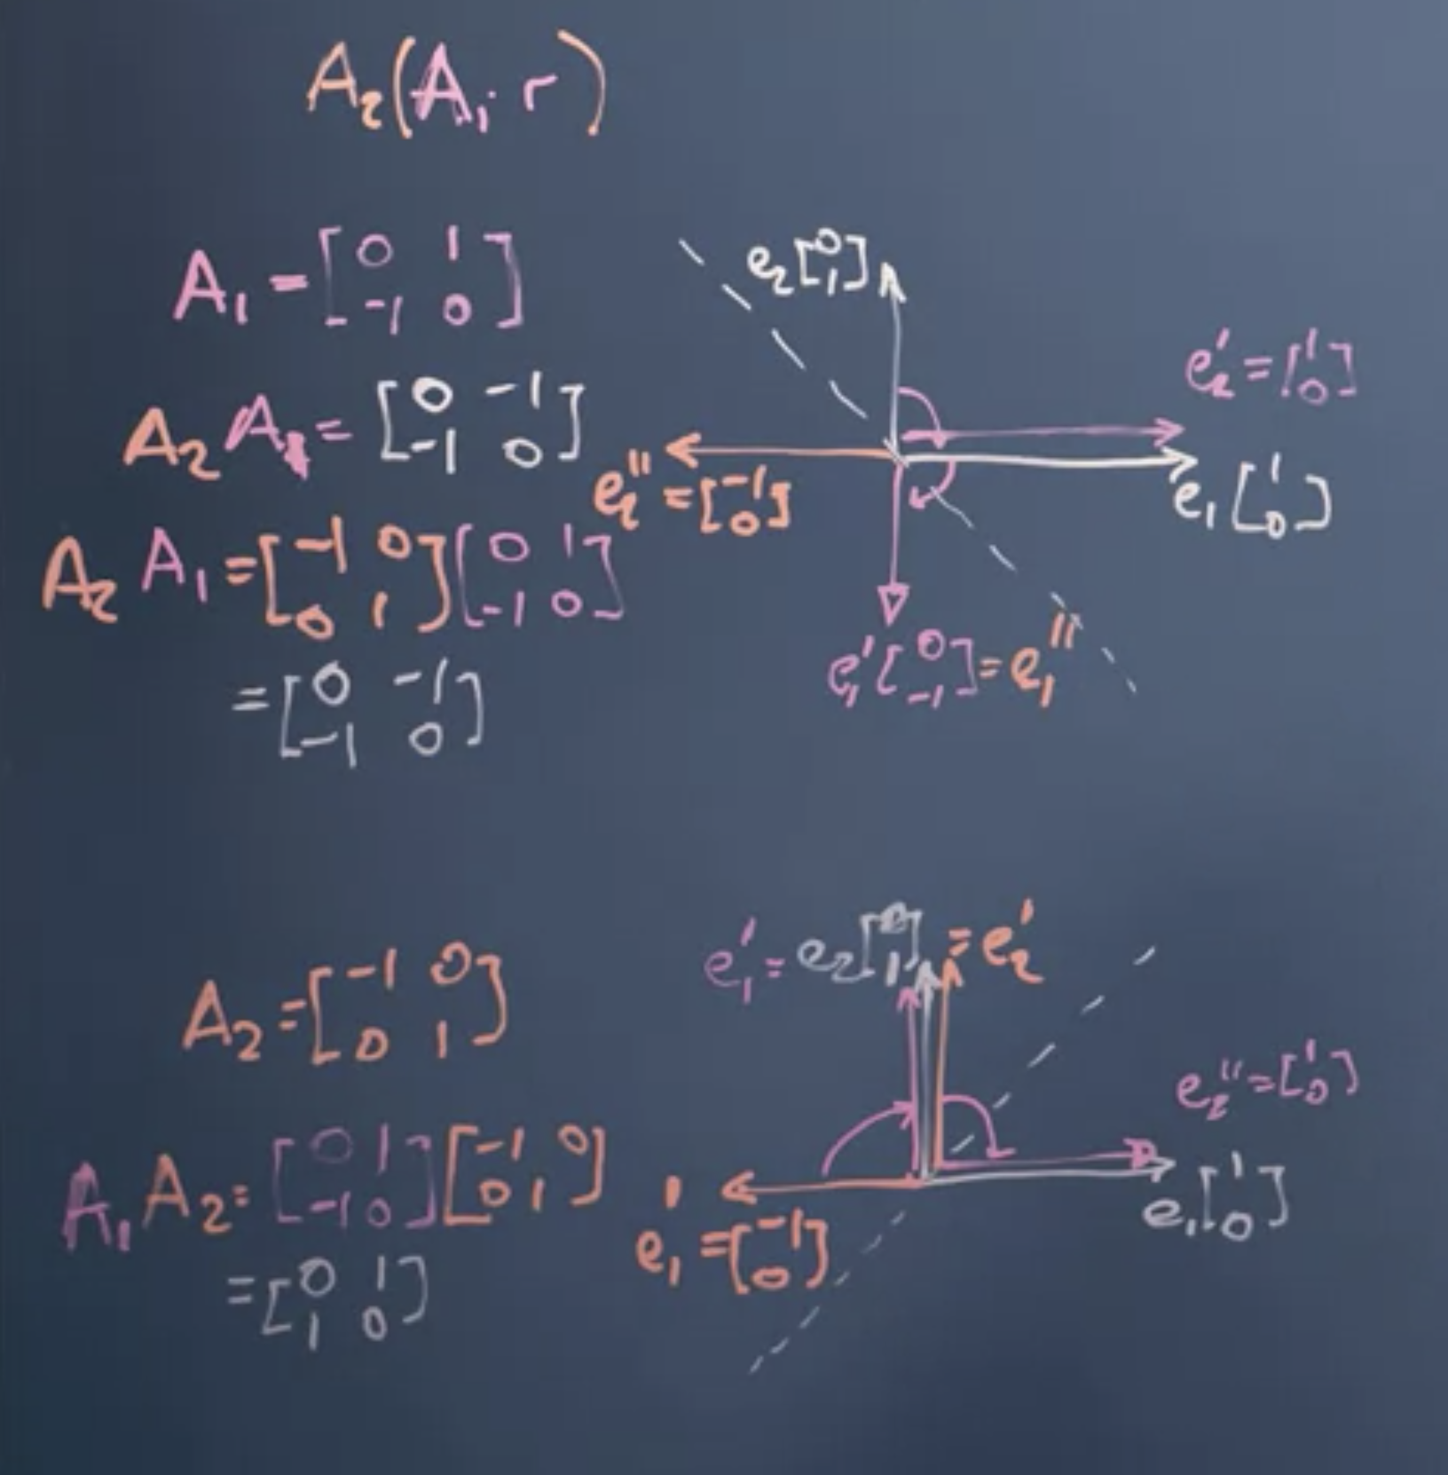

Transforming Images:



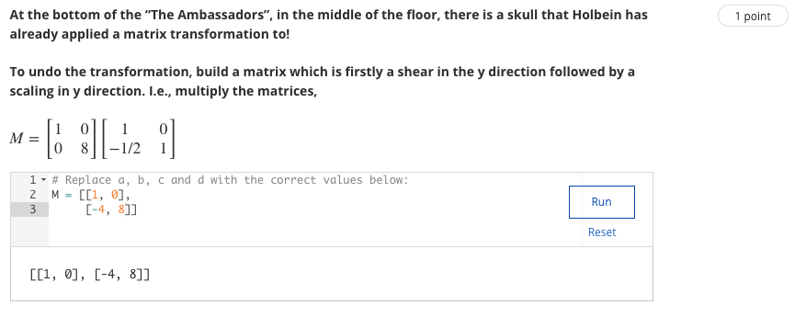

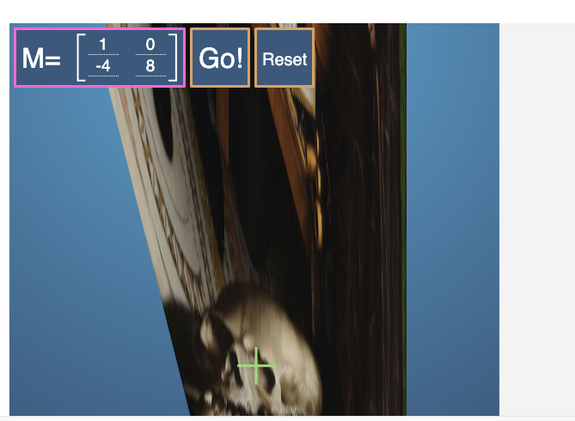

Gaussian Elimination: Solving the apples and bananas problem

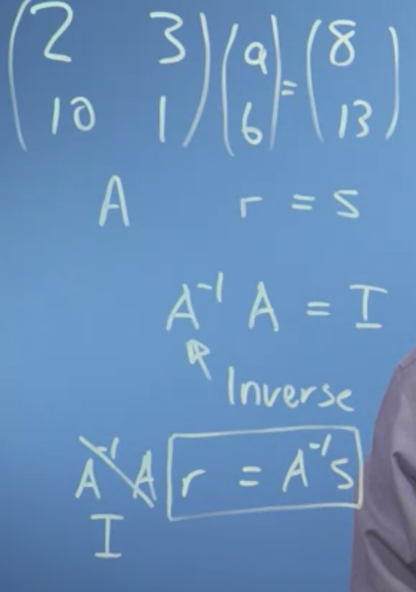

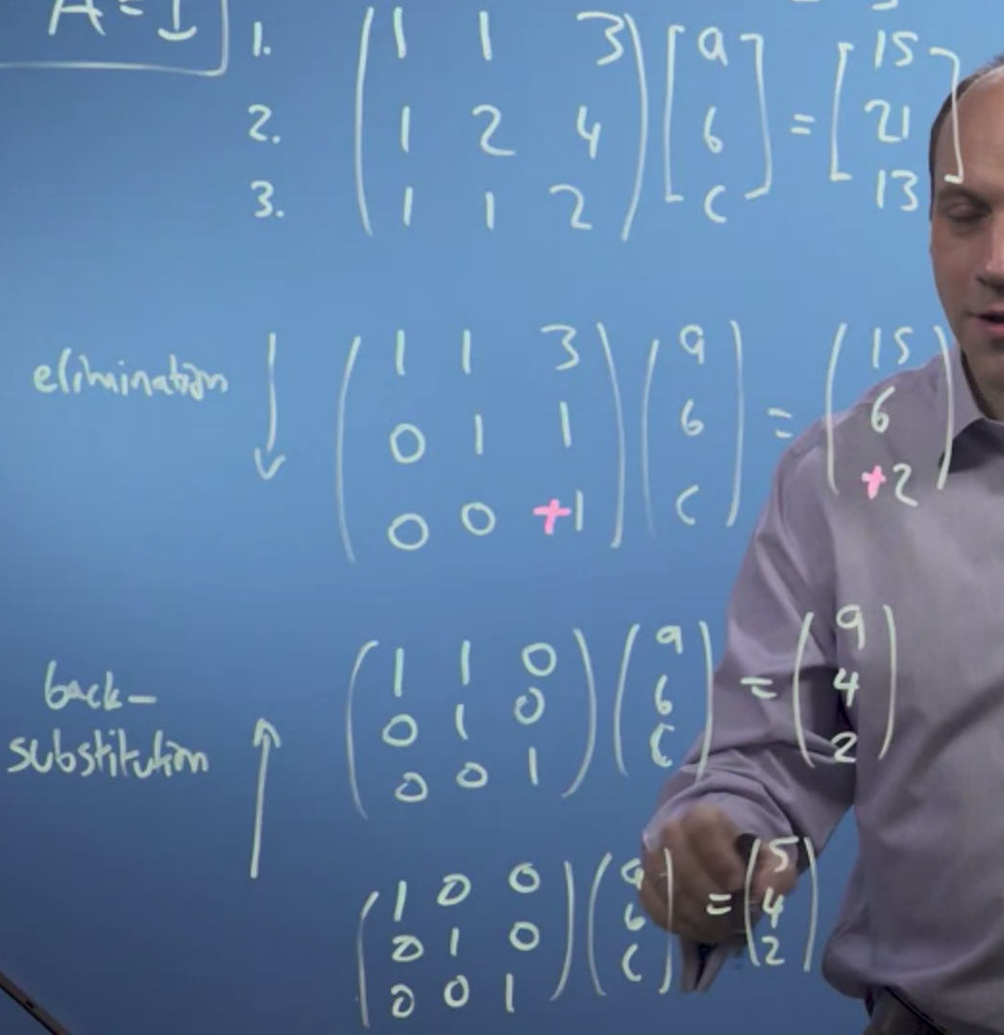

Solving the system of linear equations without taking the inverse but using the process of elimination.

Now, the thing to notice about a system of equations like this is that I can, if I take this row off of another row, I haven't changed anything, right? So, I know that an apple, a banana, and three carrots cost 15. So if I take an apple, a banana, and three carrots, and 15 off of the next row, I haven't changed anything really about that row, and the same for the third row. So, I can make this problem simpler by going and doing that, that sort of a process of elimination.

Let's change pens. And I've got a solution now for c, that c is equal to two, so that's interesting. Now, I've got what's called a triangular matrix, that is, everything below the body diagonal is zero. And that's a very interesting sort of matrix. I've reduced it to what's called Echelon form. All the numbers below the leading diagonal is zero. Now, I can do what's called back substitution.

Guassian Elimination is a faster method to find solve for the system of linear equations than taking the inverse.

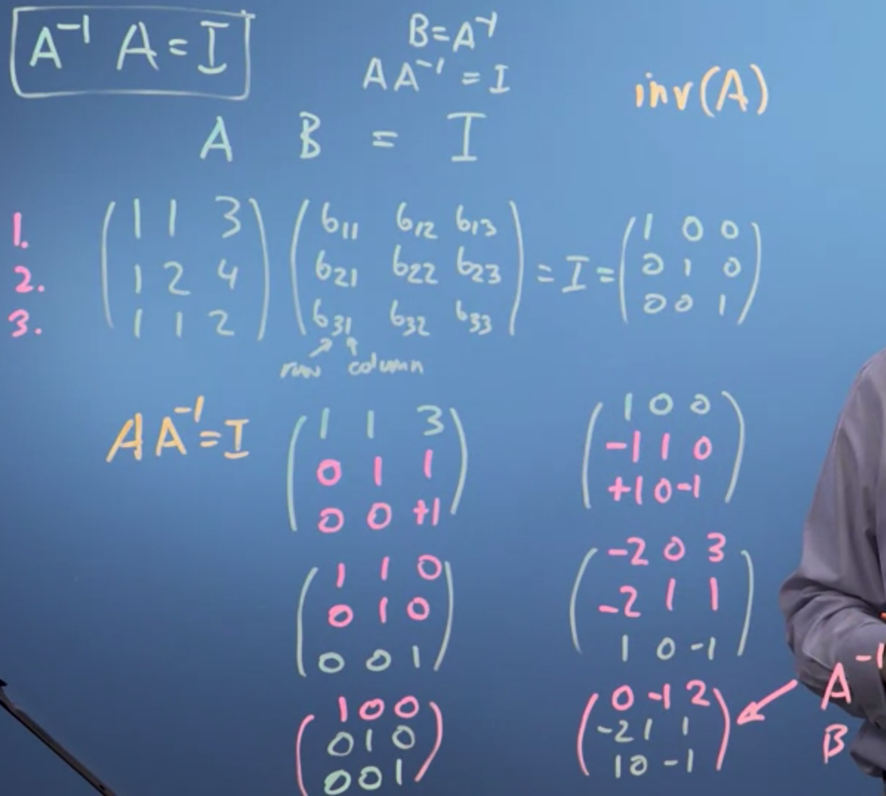

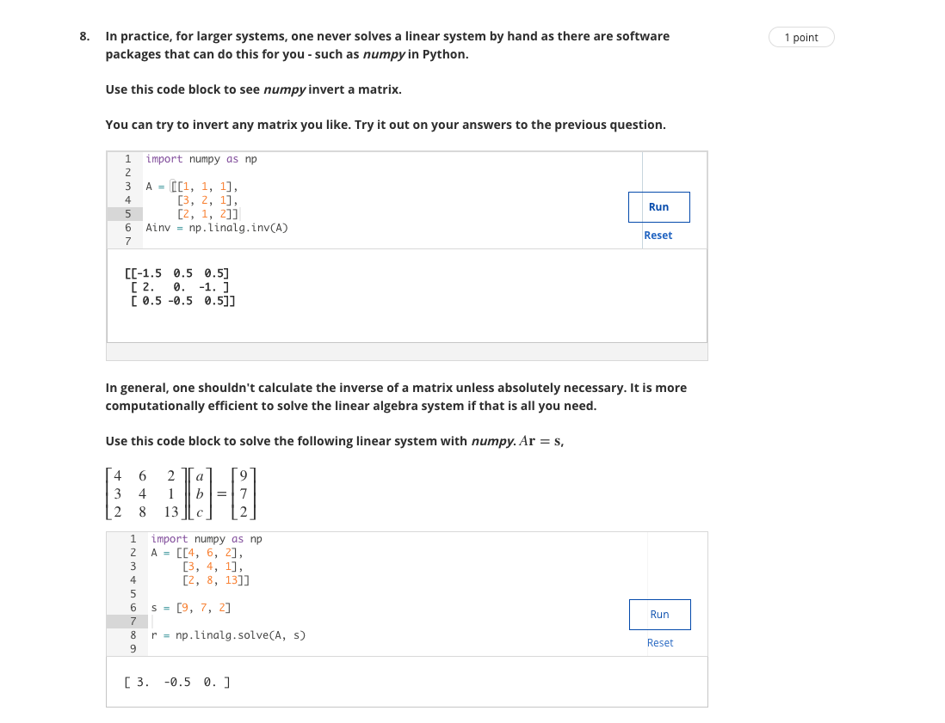

Determinant:

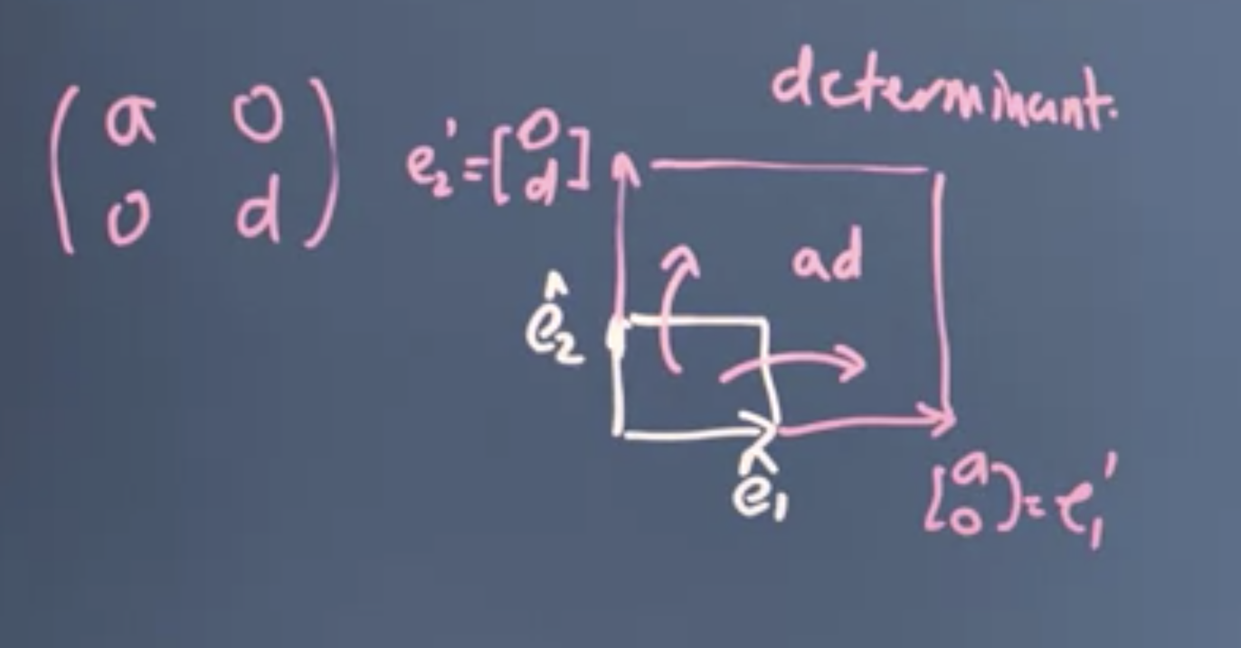

All areas in the space everything's got bigger by a factor of ad. I call that the determinant of the transformation matrix.

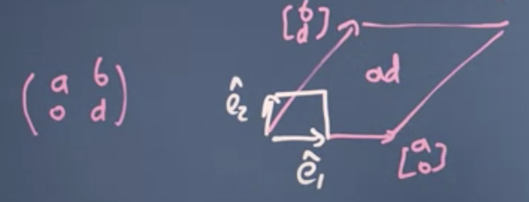

I've gone from being something like this, to being something like this I've made a parallelogram, but the area of the parallelogram is still ad. It's base times its perpendicular height. So the determinant is still ad, of this transformation matrix.

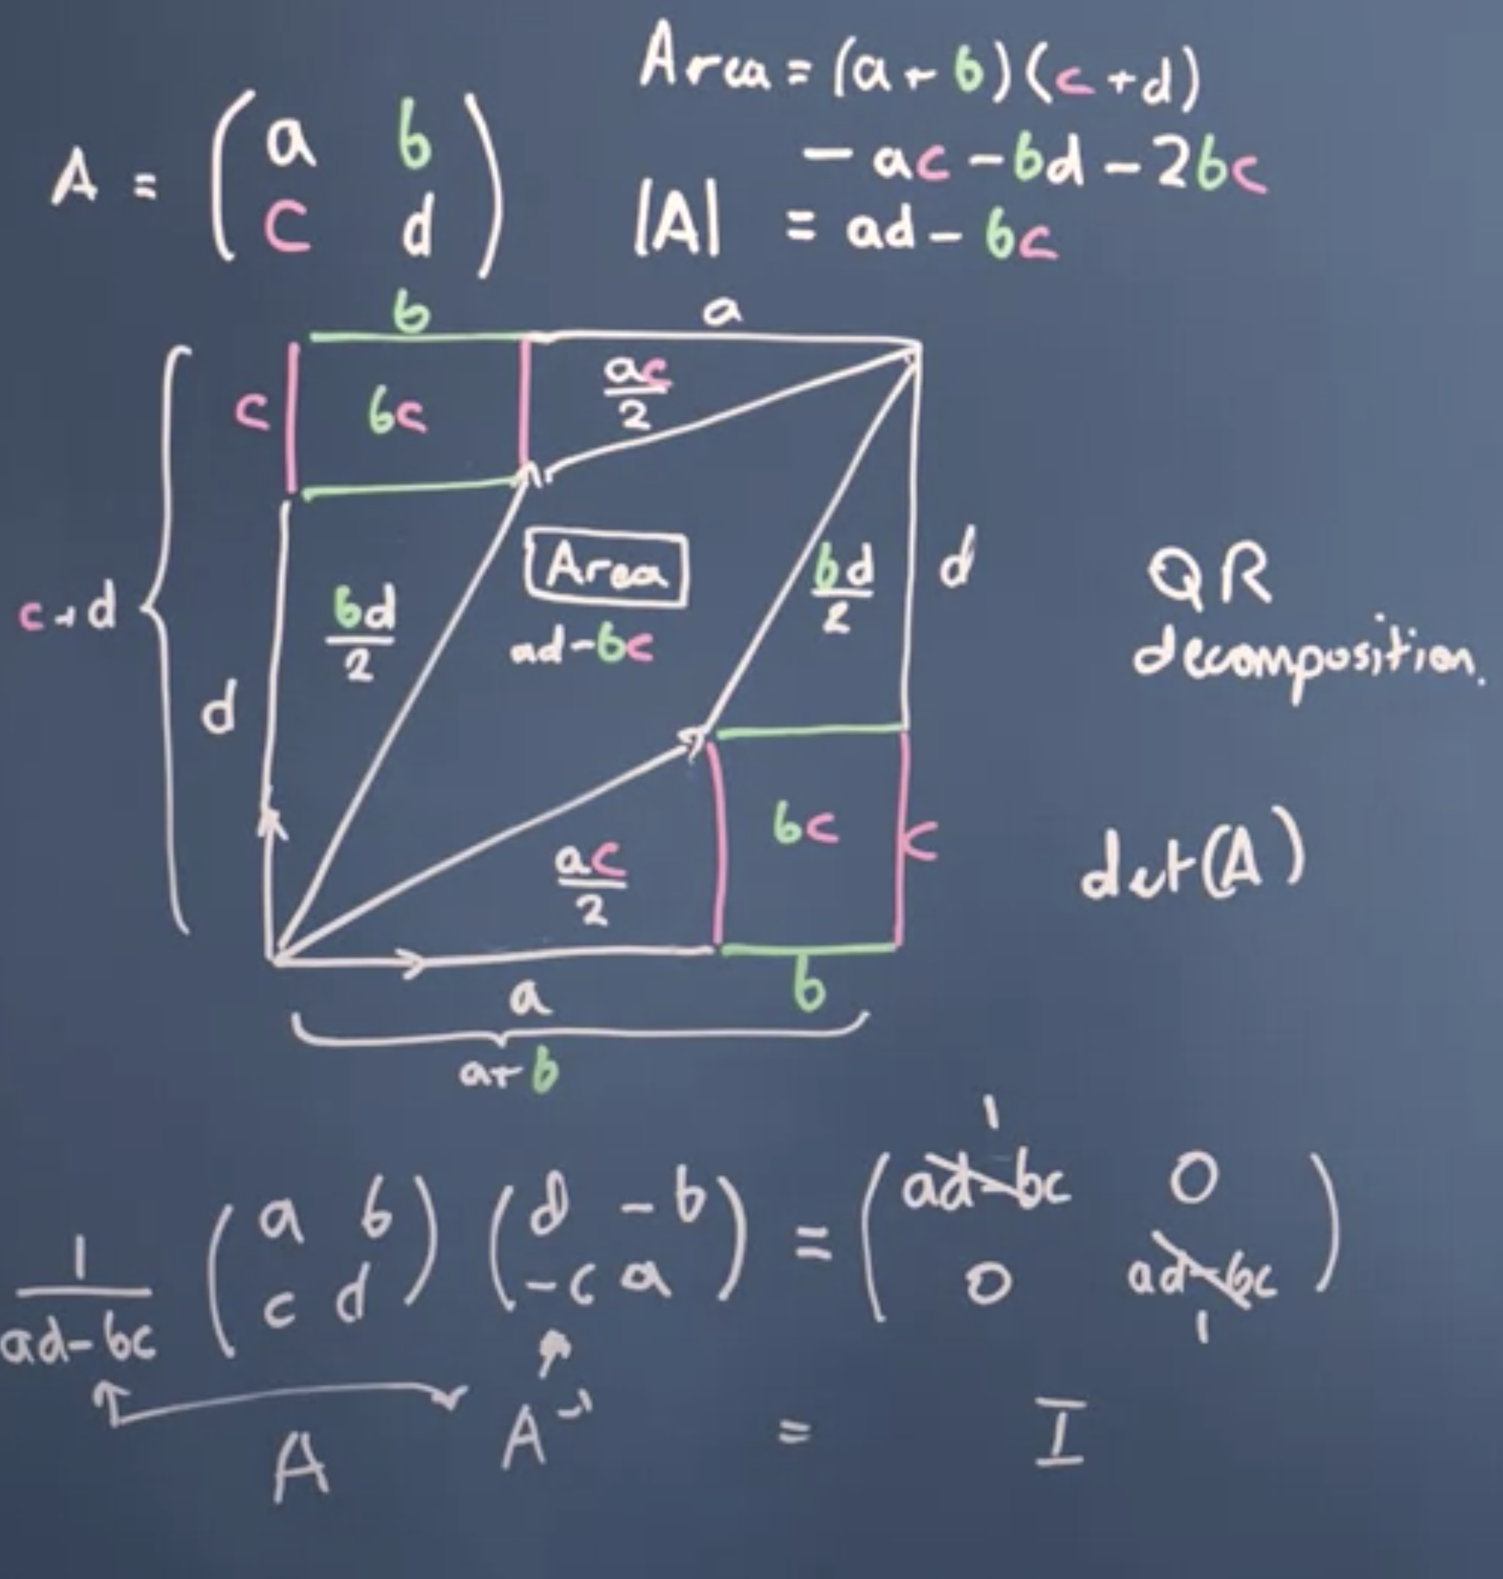

In school, when you looked at matrices you probably saw that you could find the inverse of a matrix like a, b, c, d, by flipping the terms on the leading diagonal, and taking the minus of the off-diagonal terms for two by two. f we then take this matrix when we do the flipping around we haven't changed it's scaling of space we need to undo that scaling and bring it back down to a scale of one. So the determinant here is what we need to divide the inverse matrix by in order for it to probably be an inverse.

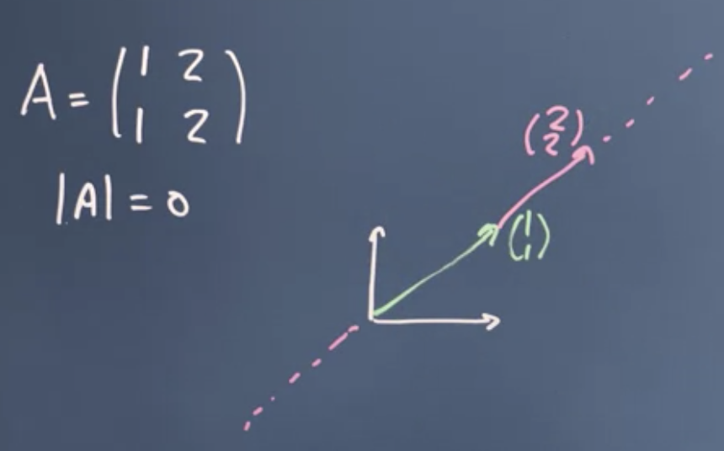

So if I had a three by three matrix with a similar situation describing a 3D space, and if I had the same position where one of the new basis vectors was just a linear multiple of the other two, it wasn't linearly independent, then now would mean the new space was either a plane or if there was only one independent basis vector, a line like we have here. In either case the volume enclose would be zero, so the determinant would be zero.

Now, let's turn back to our val echelon form and apply that idea. Let's take this set of simultaneous equations say. You can see that the third row is just the sum of the first two. So row three is equal to row one plus row two. You can see that column three is just given by two of column one plus column two. If you want to pause for a moment to verify that it really is true. So this transformation matrix doesn't describe three independent basis vectors. One of them is linearly dependent on the other two.

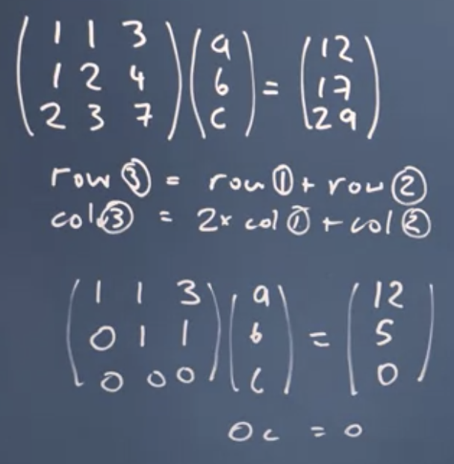

So now I've got zero C equals zero, which is sort of true but not useful. Then an infinite number of solutions for C in effect, any value of C would work. So now I can't solve my system of equations anymore, I don't have enough information. So if we think about this from solving simultaneous equations point of view, my mistake was when I went into the shop to buy apples, bananas, and carrots, the third time I went in I just ordered a copy of my first two orders. So I didn't get any new information and I don't have enough data therefore to find out the solution for how much I individual apples and bananas and carrots costs.

**Important:**

So, what we've shown is that where the basis vectors describing the matrix are linearly independent, then the determinant is zero, and that means I can't solve the system of simultaneous equations anymore. Which means I can't invert the matrix because I can't take one over the determinant either. That means I'm stuck this matrix has no inverse. So there are situations where I might want to do a transformation that collapses the number of dimensions in the space but that will come at a cost. Another way of looking at this is that the inverse matrix lets me undo my transformation, it lets me get from the new vectors to the original vectors. If I've done two dimension by turning a 2D space into a line, I can't undo that anymore, I don't have enough information because I've lost some of it during the transformation, I've lost that extra dimension. So in general, it's worth checking before you propose a new basis vector set and then use a matrix to transform your data vectors, that this is a transformation you can undo, by checking that the new basis vectors are linearly independent.

Matrix is Singular?

When is the 4×4 matrix is singular, i.e. to determine if an inverse exists, before calculating it

1. Get the determinant, if it is zero
2. Converting a matrix to echelon form, and testing if this fails by leaving zeros that can’t be removed on the leading diagonal.